March 20, 2024

Hello CSMS 55+ Members
Welcome to spring and that means we will be out playing ball in a few weeks.
Spring Meeting
There will be more information about all items in this notice at the Spring Meeting; 7pm at Triwood Community Centre April 17, 2024 Collingwood Room.
Diamonds have been secured for AAA for the 2024 Season.
We have 2 diamonds at Club YC, which we will call Aero, and one diamond at Webber Athletic Academy. All diamonds are about 300’ with 7 to 8 foot fences; a true AAA outfield. Of the 15 week schedule, all teams will have 5 nights at Webber and 10 nights at Aero. And yes, both facilities are licensed and will have refreshments available after the ball games.
Aero will be Tuesday nights with both diamonds active so 4 teams on Tuesday and Webber will be Thursday nights with the final two teams playing rounding out the weekly schedule.
Aero Diamonds
567 Aero Dr NE, Calgary, AB T2E 8P6
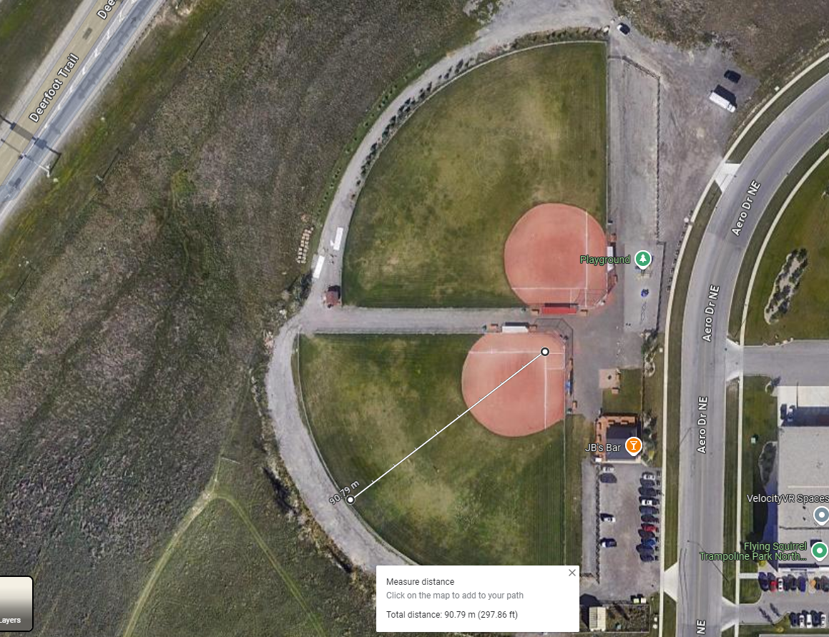

Webber Athletic Field House
32070 Lower Springbank Rd
Calgary, AB T3Z 2M7
Evaluations are at this Webber location on April 27th at a 10 am start time. New members are encouraged to attend the Spring Meeting on April 17 for more information.

This world class facility is a 100% artificial turf infield and outfield at Webber with about a 300’ fence. The diamond we will use is outlined in red in the image below.
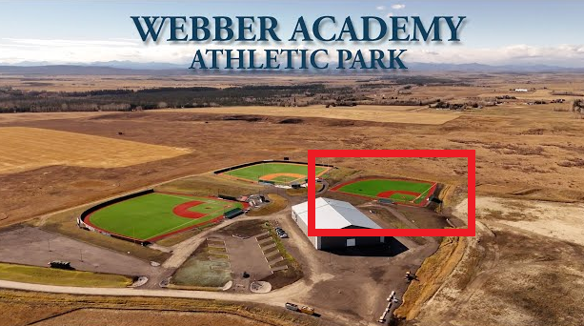

Rules Clinic
There is a Rules Clinic set for April 13 at Triwood Community Center in the Foothills room from 10am to 1pm. This used to be called the Umpires clinic but Rules clinic is more indicative of the nature of the content. Any league member can attend, but it is recommended managers and coaches attend, and any league member wanting to become a new umpire must attend. Register through Dave Finn so he knows how many to expect. (davefinn@shaw.ca)
Umpires
Speaking of umpires, CSMS will not be using SPN umpires for the 2024 season so we will require players from within our league to step into umpiring positions. This will be critical for AAA on Tuesdays where we have 4 teams playing, we will only have 2 teams not playing which will need to supply umpires. If you have been thinking about umpiring, now is the time to start. Not to mention the exceptional pay, imagine the prestige! Also, a great way to become involved in making our league progress forward and maintain sustainability.
Division Representatives
This year’s Division Reps are Gus Carlson(A), Bruce Hall(AA) and Dave Curtis(AAA). We have also created email address for each rep so when anyone need contact the division rep, there is a simple address that will not change from year to year. AAAdivisionrep@grandslamslopitch.com, AAdivisionrep@grandslamslopitch.com, Adivisionrep@grandslamslopitch.com.
Fields
There will also be an email address created that will be designed for contacting our Field Rep and our fabulous field crew. However, the grandslamslopitch page is cumbersome to create numerous recipients from a single email address so expect an new email address for fields to be announced at the Spring Meeting.
Triwood Black Out Dates
As part of our agreement with Triwood, they supply us some dates where their facility is either too busy or require the fields for kids activities. So yes, we have the Triwood diamond from Monday to Sunday but be aware these dates are blacked out.
Triwood Diamond not available:
- April 13, 20, 21 – Foothills Little League Umpire Training. Booked prior to signing our agreement.
- June 20 – Triwood Soccer Day/Wrap Up Celebration
- July 7 – Stampede Breakfast

Tournaments
We still don’t have a clear picture of any diamond availability through the summer to host tournaments, for this reason the Directors have decided there will not be a Mike Church Tournament this year. We are hoping to have an update by the Spring Meeting but it is surprising how little diamond capacity there is in and around Calgary, especially when one is looking for numerous diamonds for a weekend.
Casino
Our casino is scheduled for August 20, 21 2024. When the call comes for volunteers, keep in mind how important this casino is to us. Playoffs will be starting that week so we will offer more discussion on this at the spring meeting.

Regards
CSMS 55+ BoD

